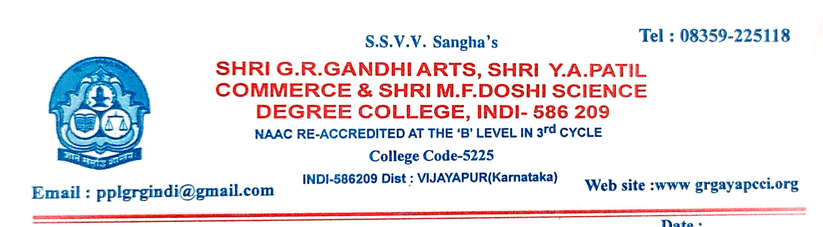
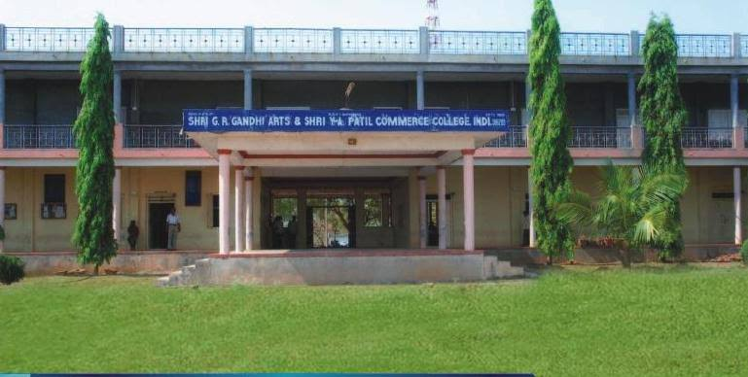

CRITERION VII - INSTITUTIONAL VALUES AND BEST PRACTICES

7.1 - Institutional Values and Social Responsibilities

7.1.1 - Measures initiated by the Institution for the promotion of gender equity during the year

ANNUAL GENDER EQUITY SENSITISATION ACTION PLAN 2021-22
SI NO | Activity | Participants | Action plan
01 | Health Food and Hygiene Programme | Students and Staff | - Better hygiene leads to to better health, Confidence and overall growth.  - Good hygiene is critical for preventing the spread of infectious diseases.
02 | International Women’s Day | Students and Staff | - To bring awareness about the Celebration of International Women’s Day.  - To know about Women leadership.
03 | Savitribai Pule Jayanti | Students and Staff | - Progressive thoughts and contribution towards women’s education and society.
04 | Women Rights and Gender equality in politics | Students and Staff | - Awareness programme and campaign on Women Rights and Gender equality in politics.
05 | Gender discrimination laws in India | Students and Staff | - Awareness programme for the gender percentage and equality in India.

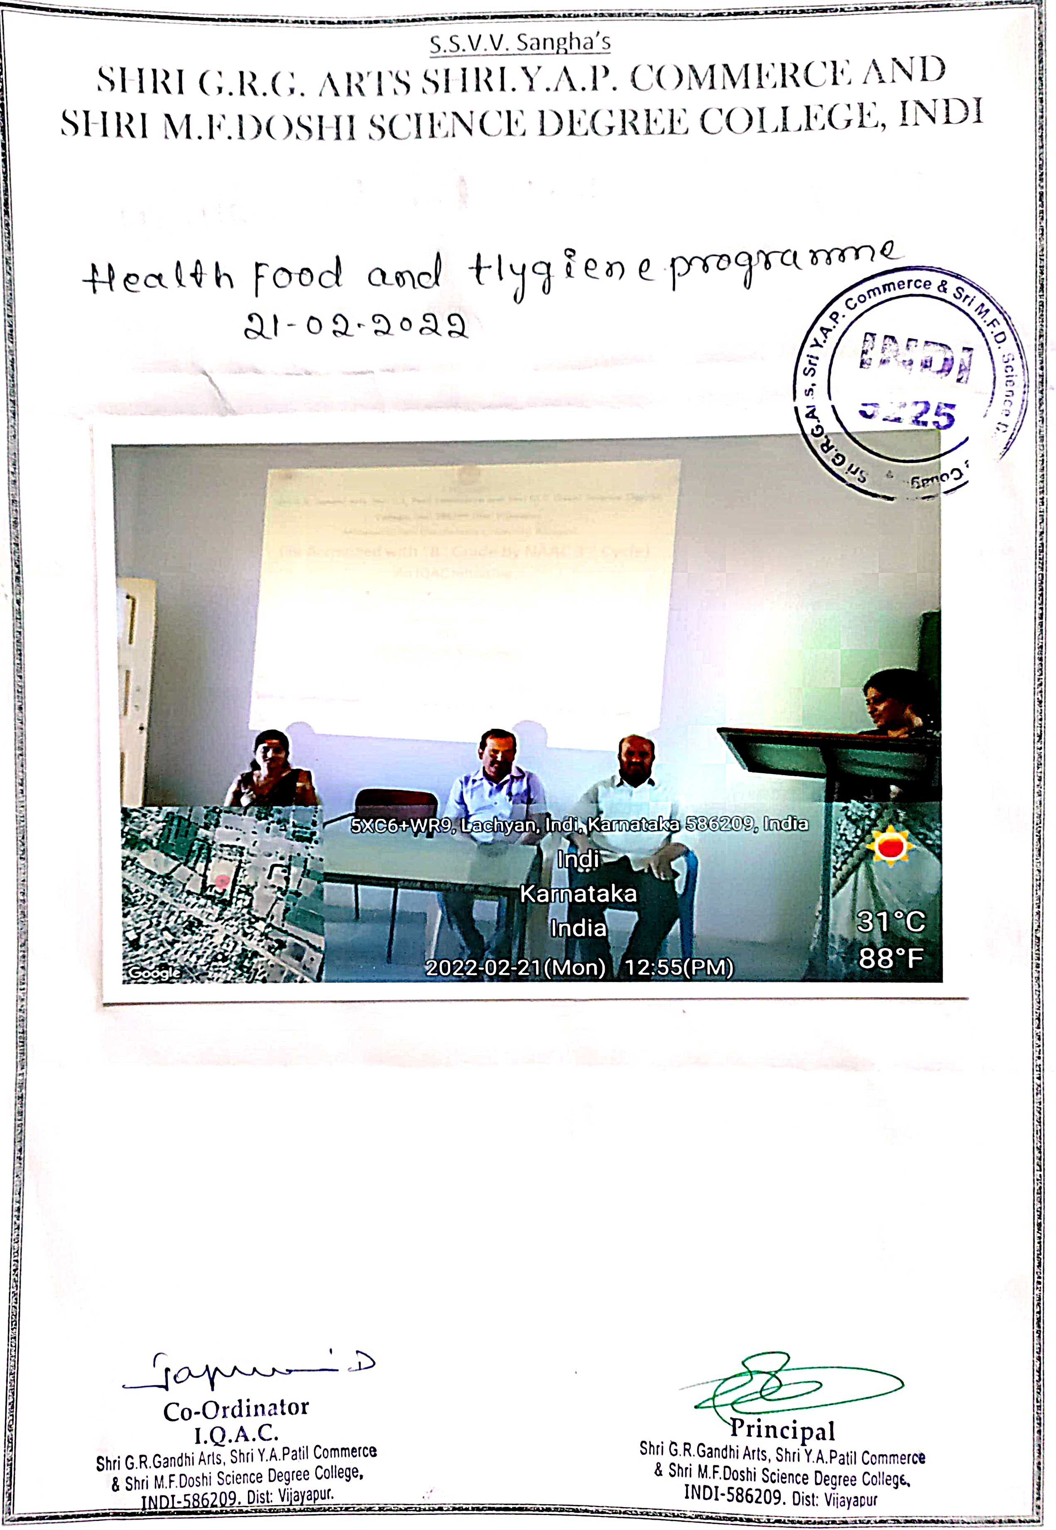

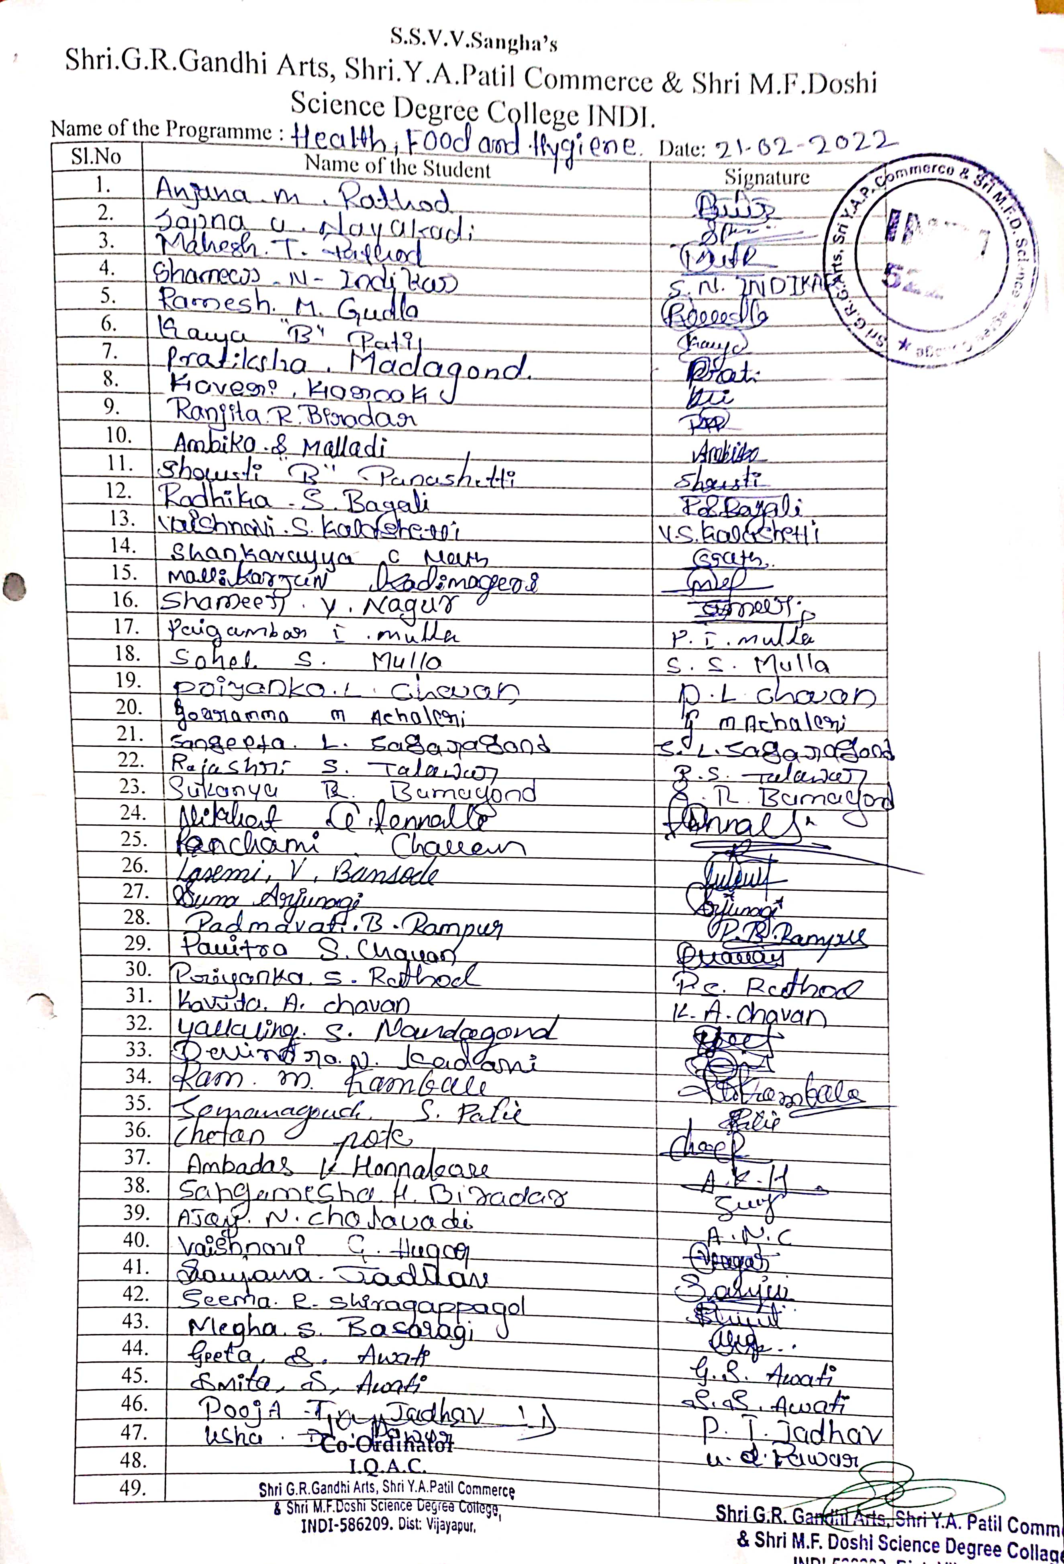
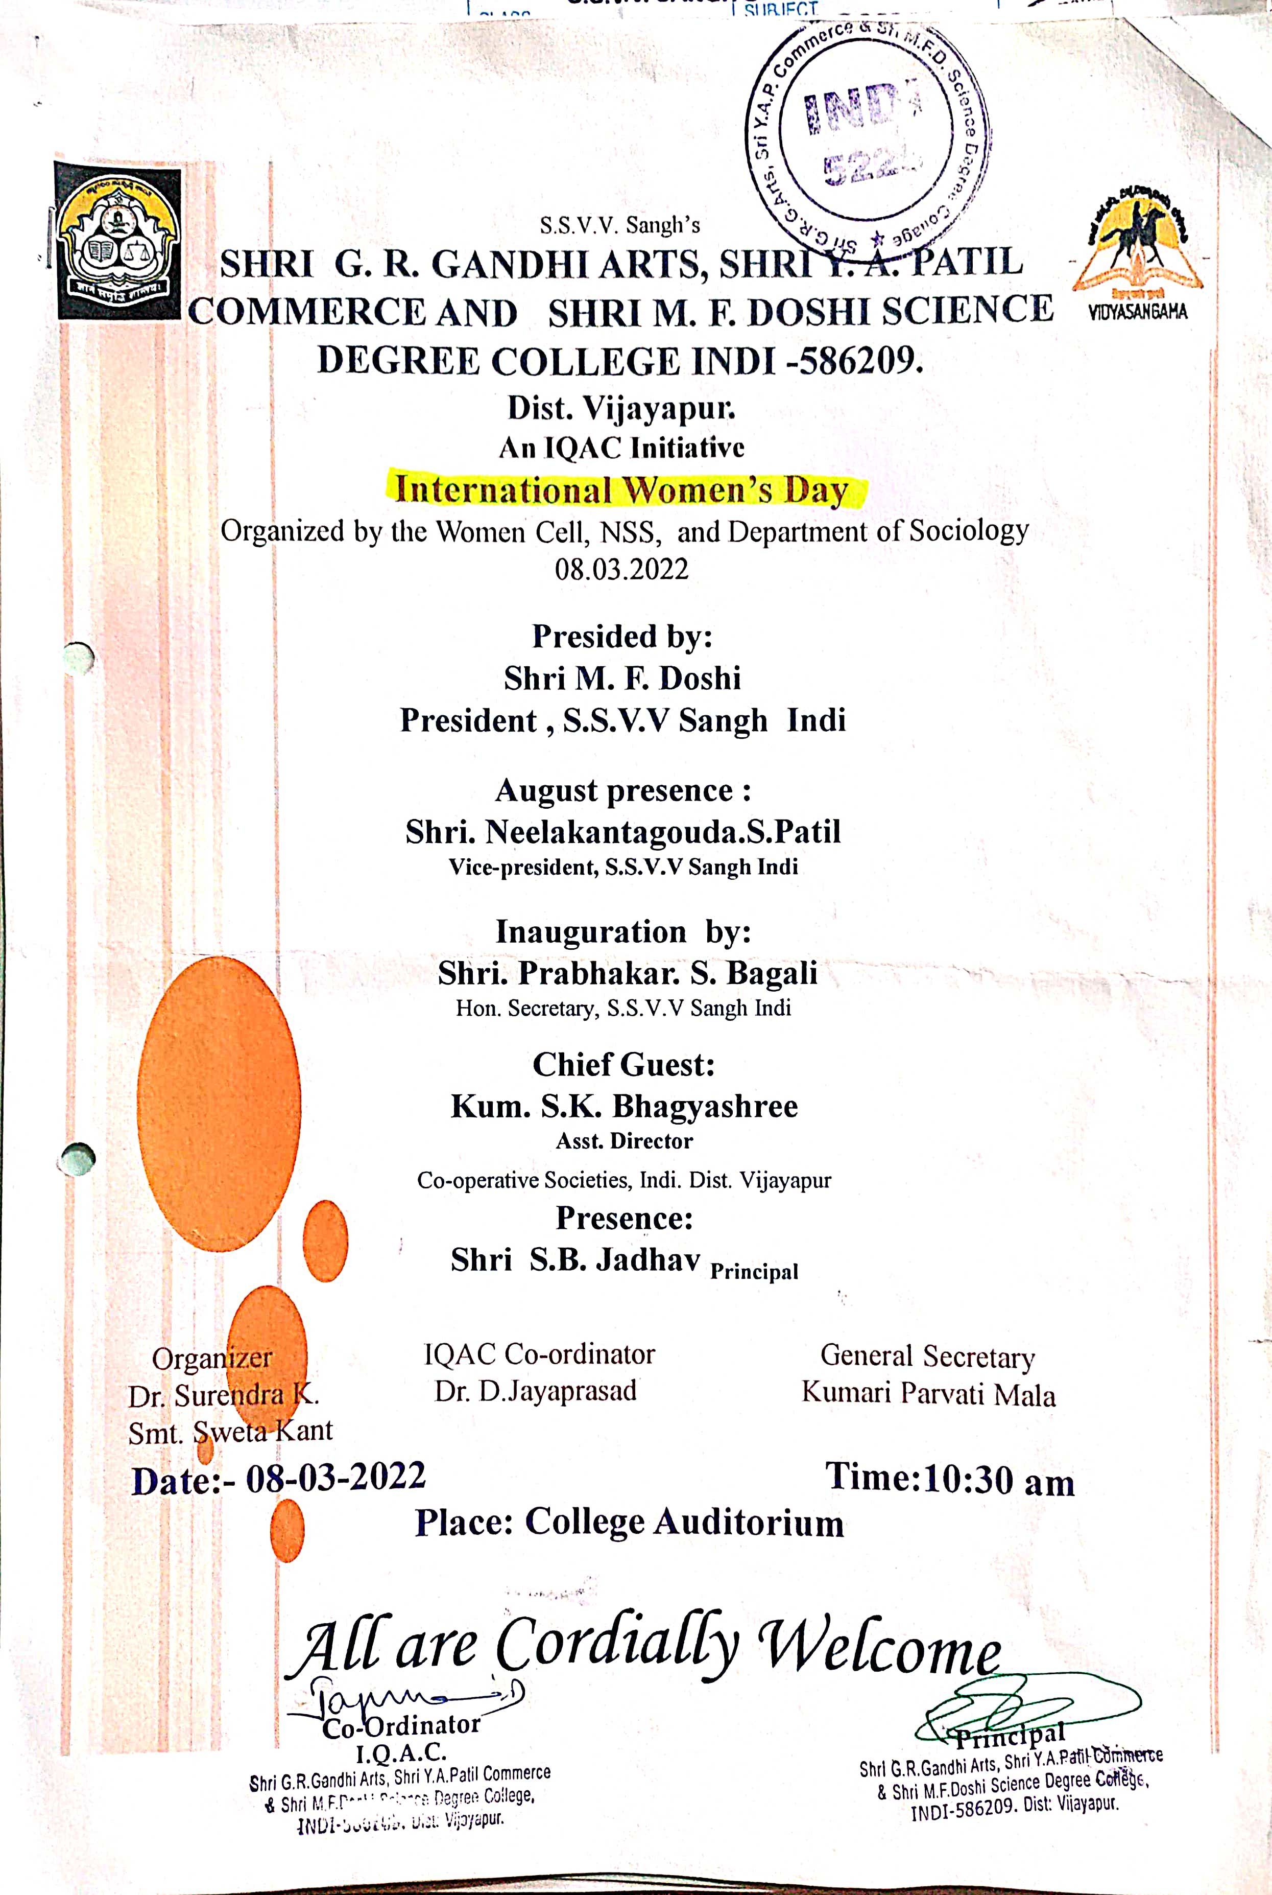
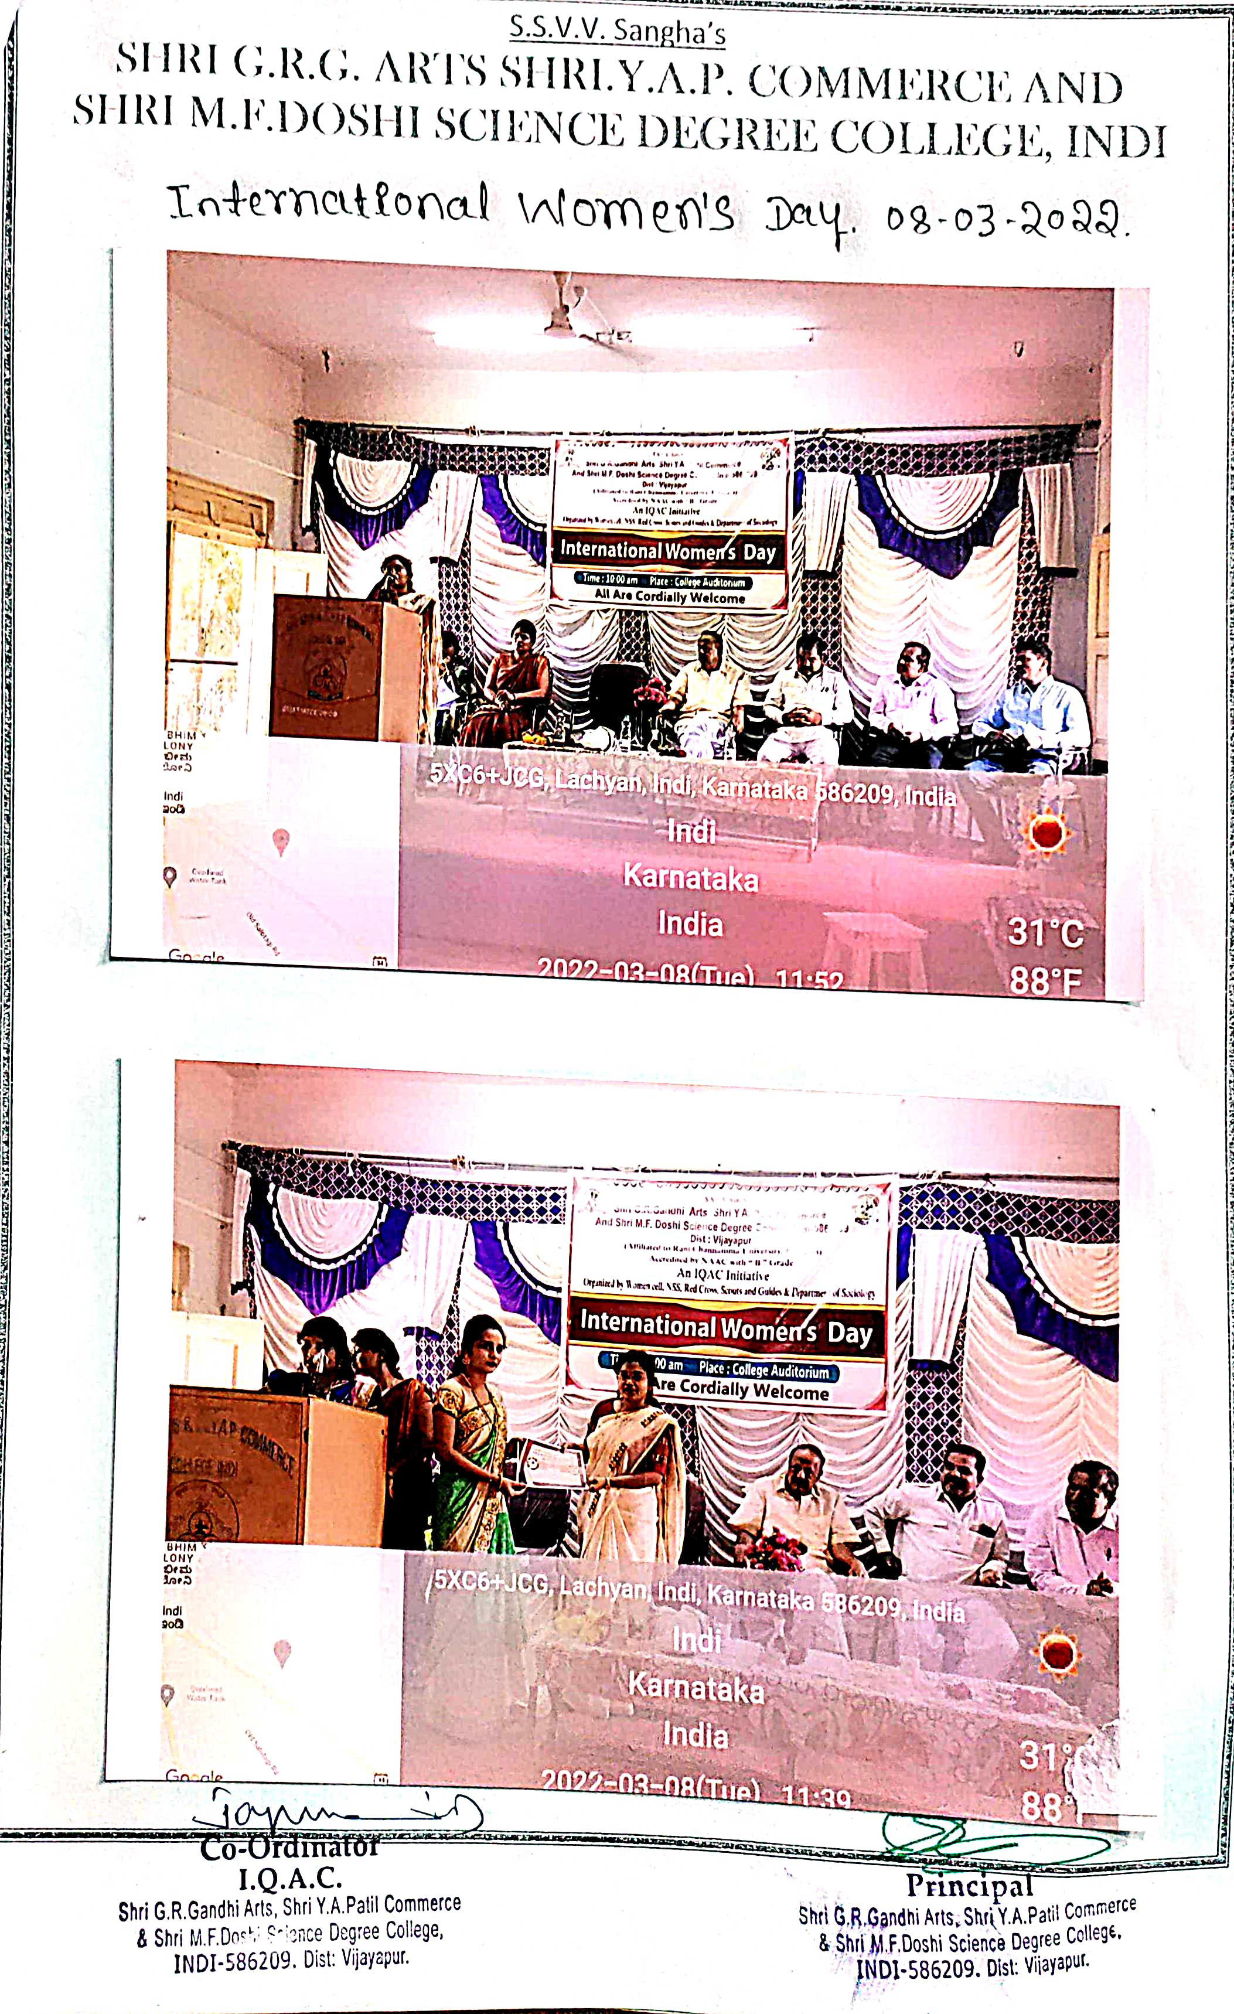
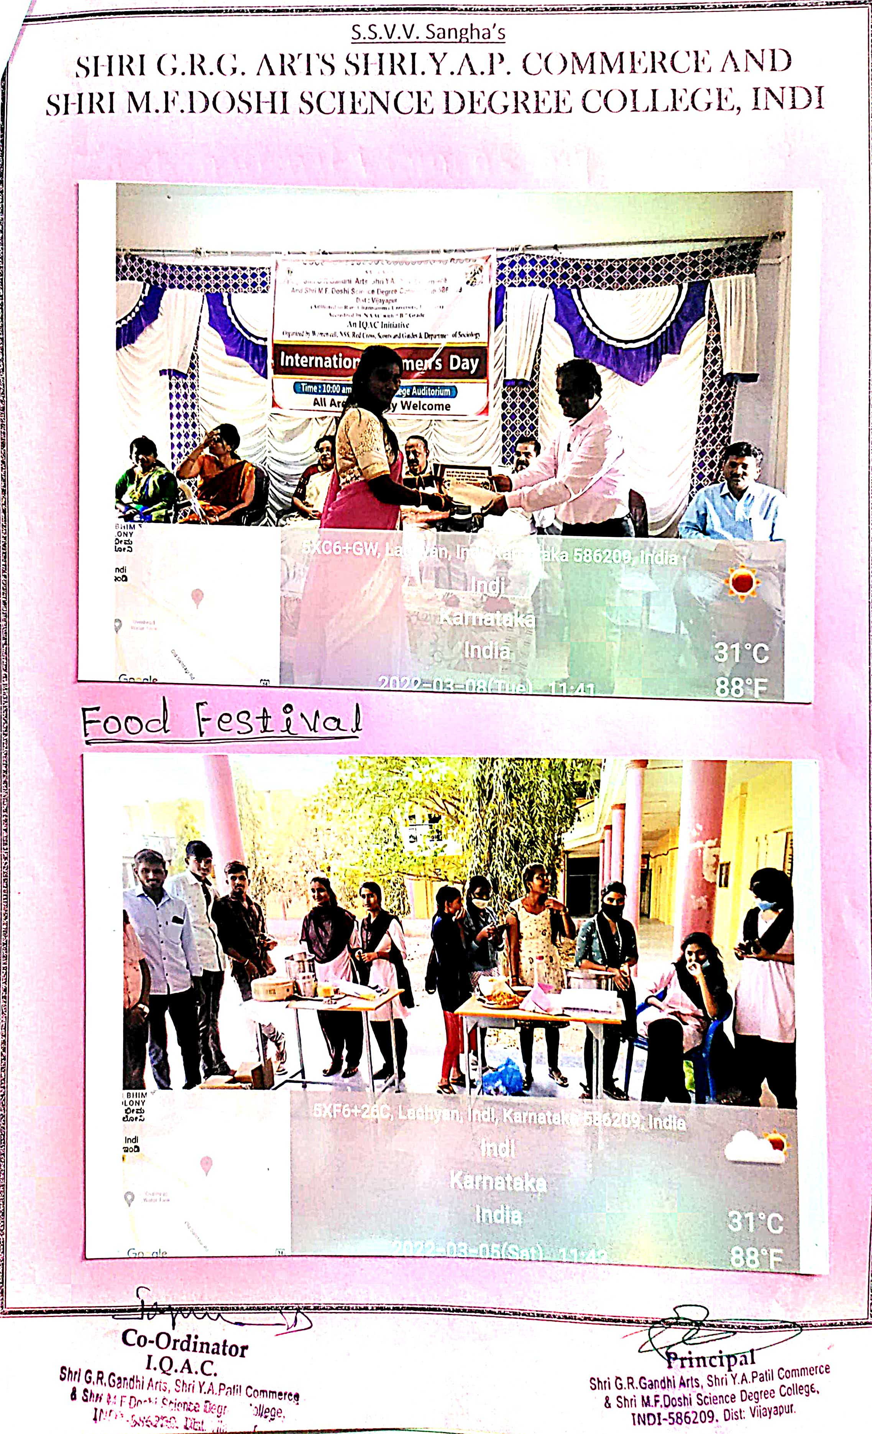

PAINTING COMPETITION ON WOMEN RELATED
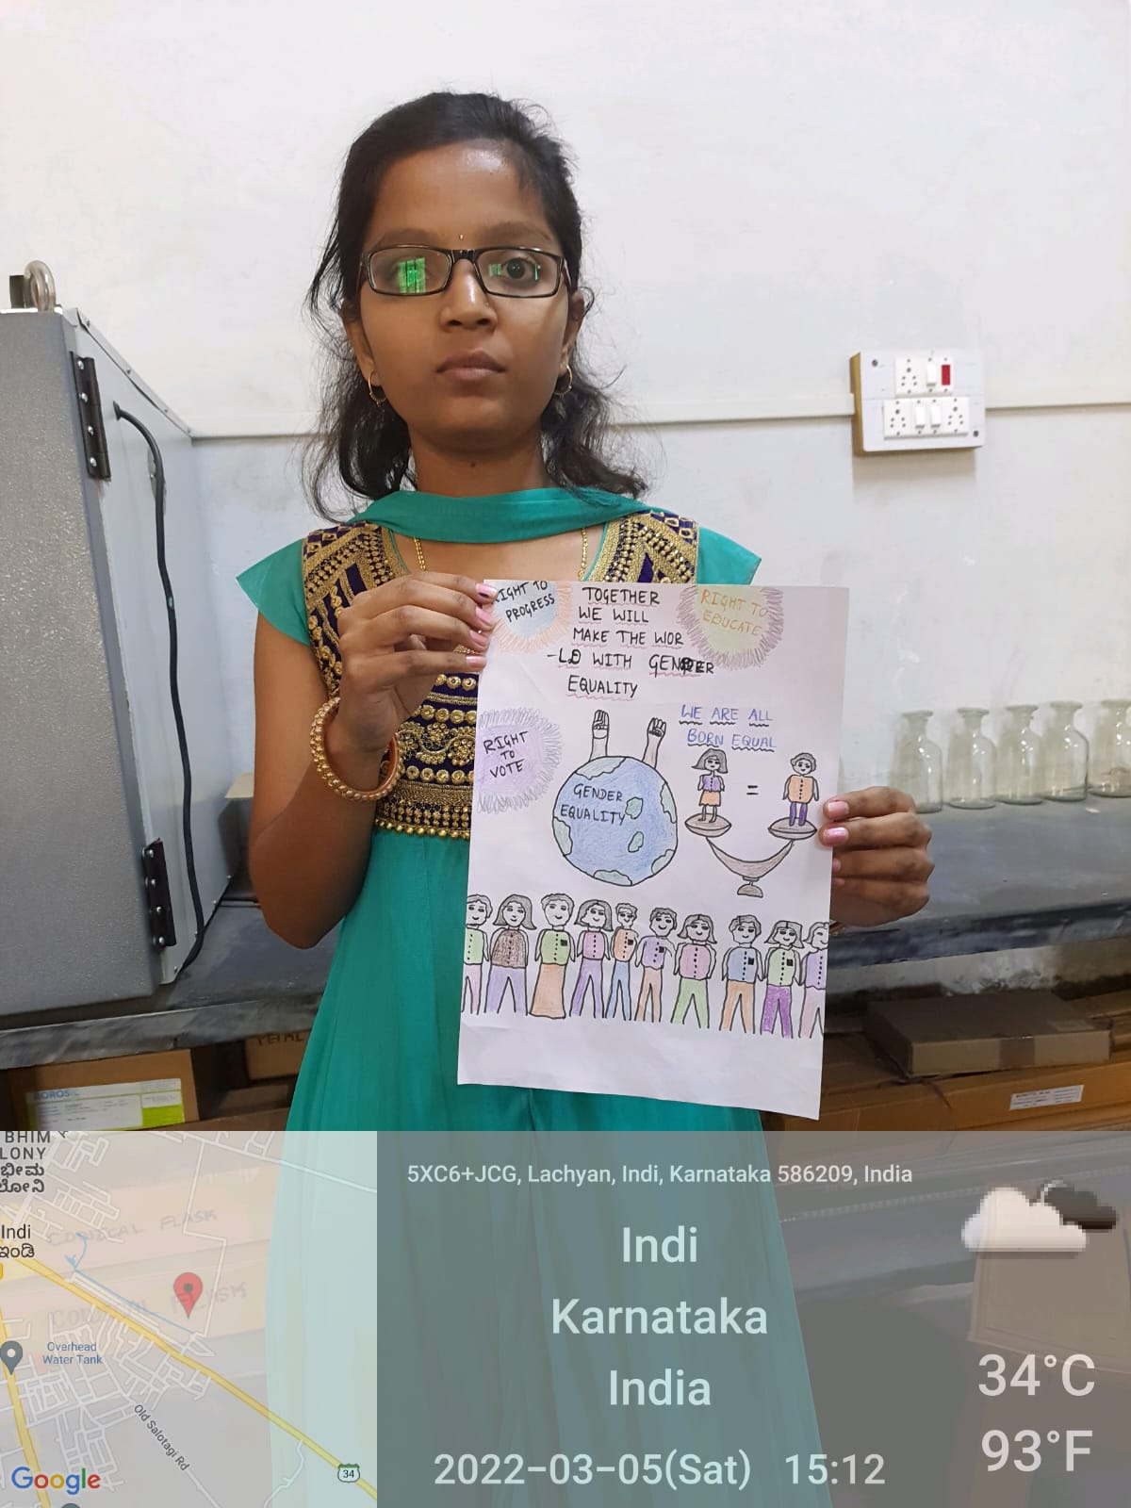
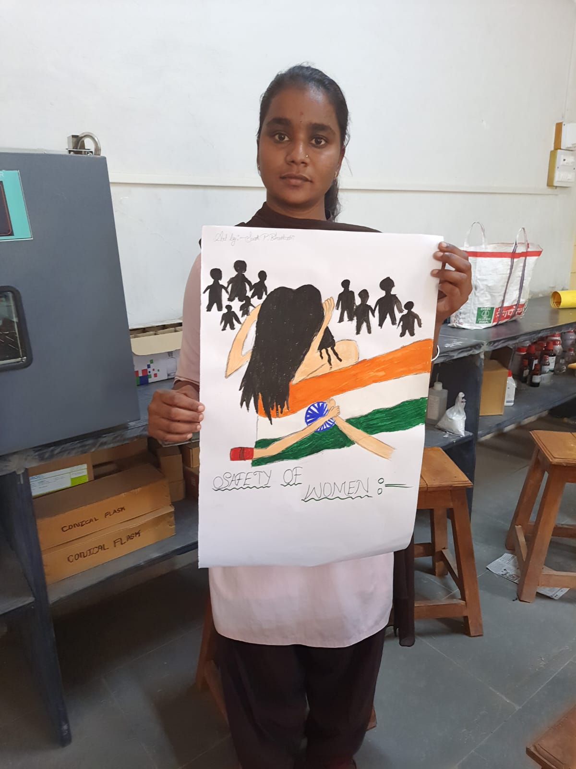

CLAY MODELLING
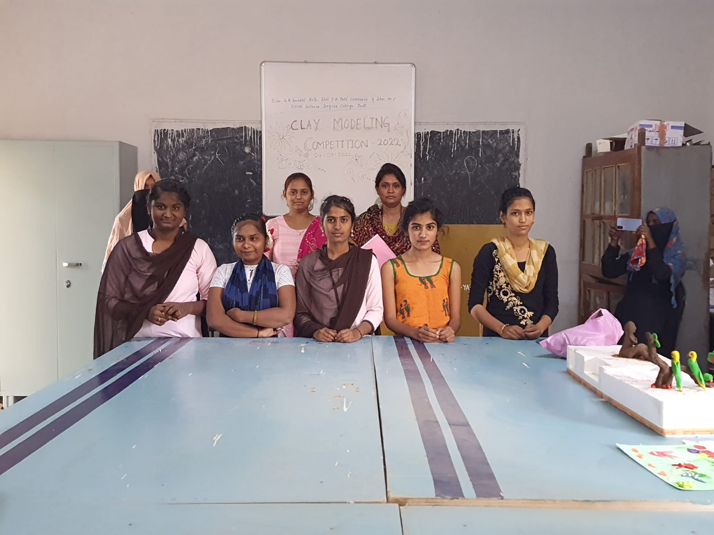
HAIR STYLE COMPETITION
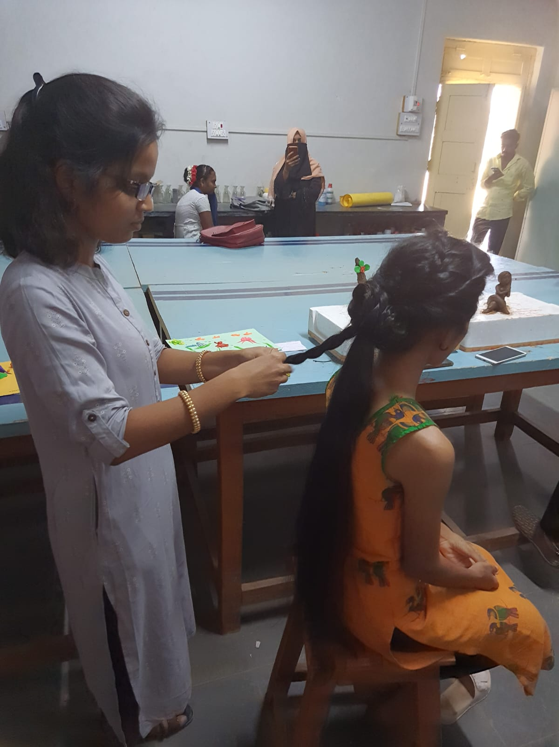
FOOD FESTIVAL
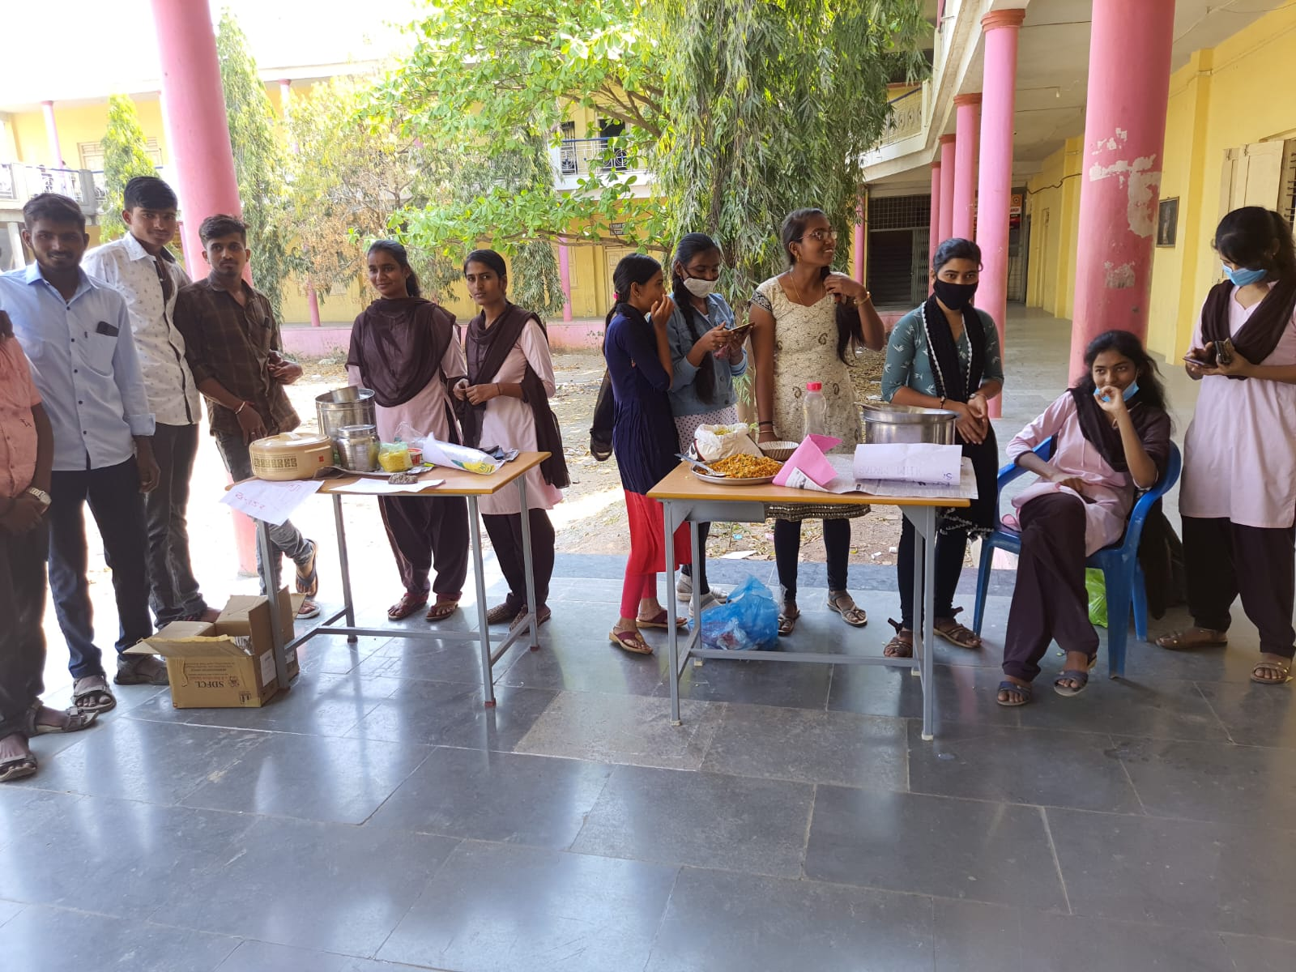
MEHANDI COMPETITION
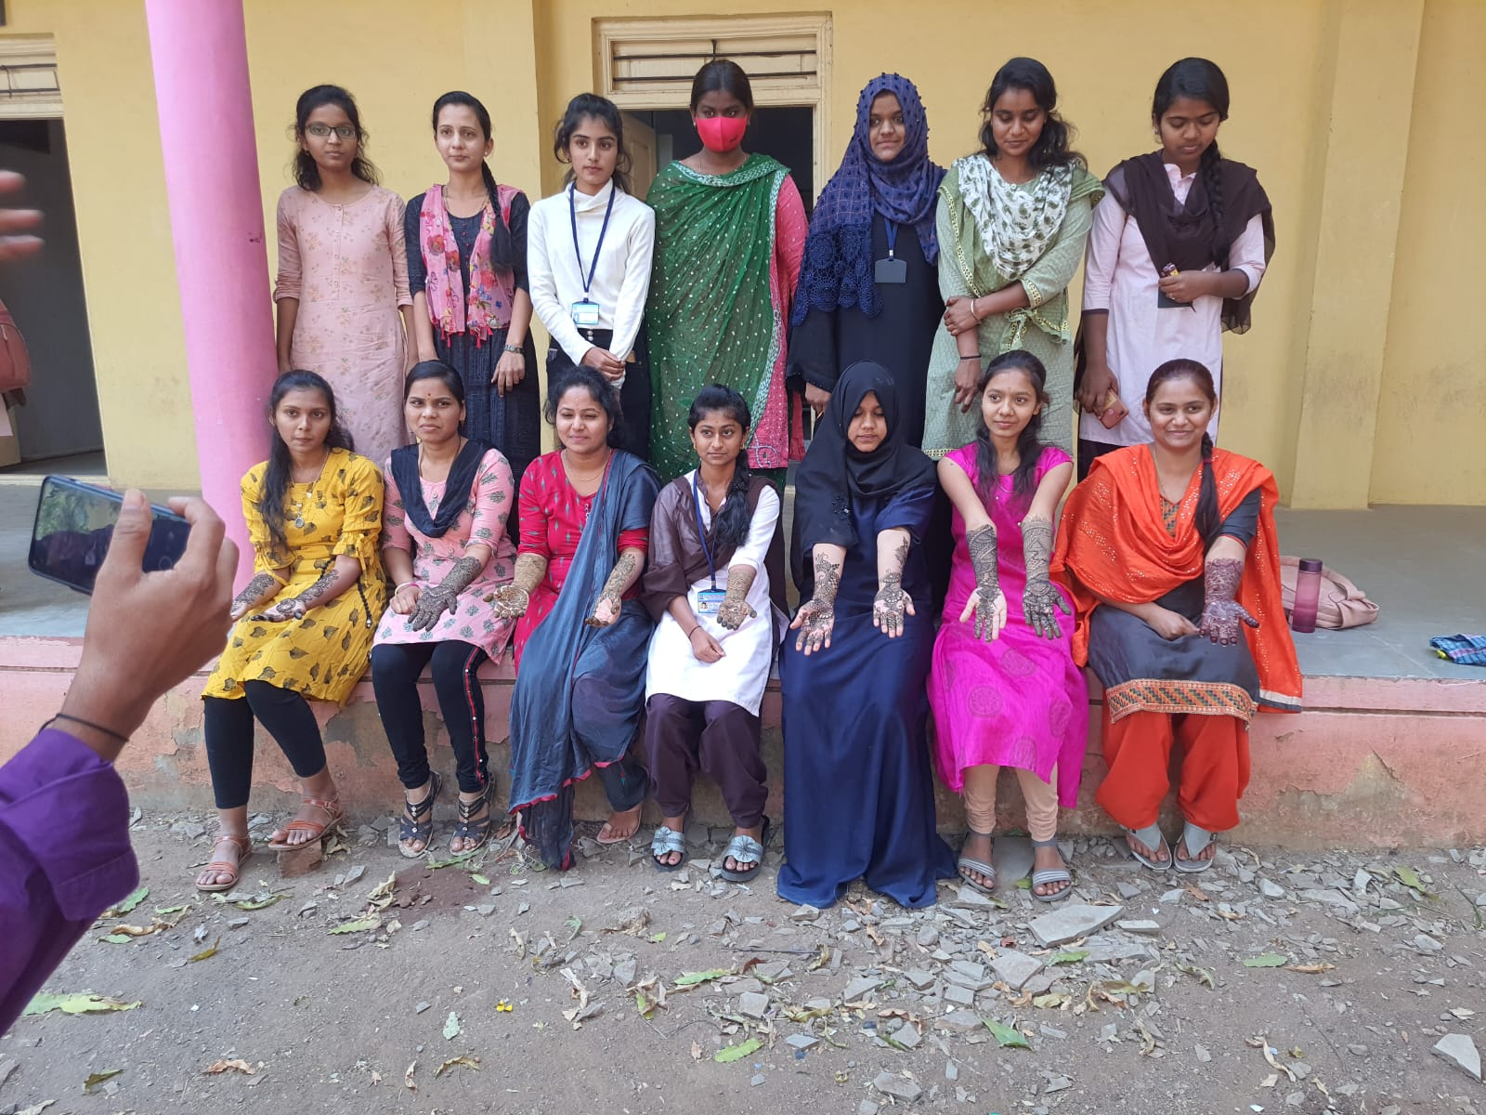
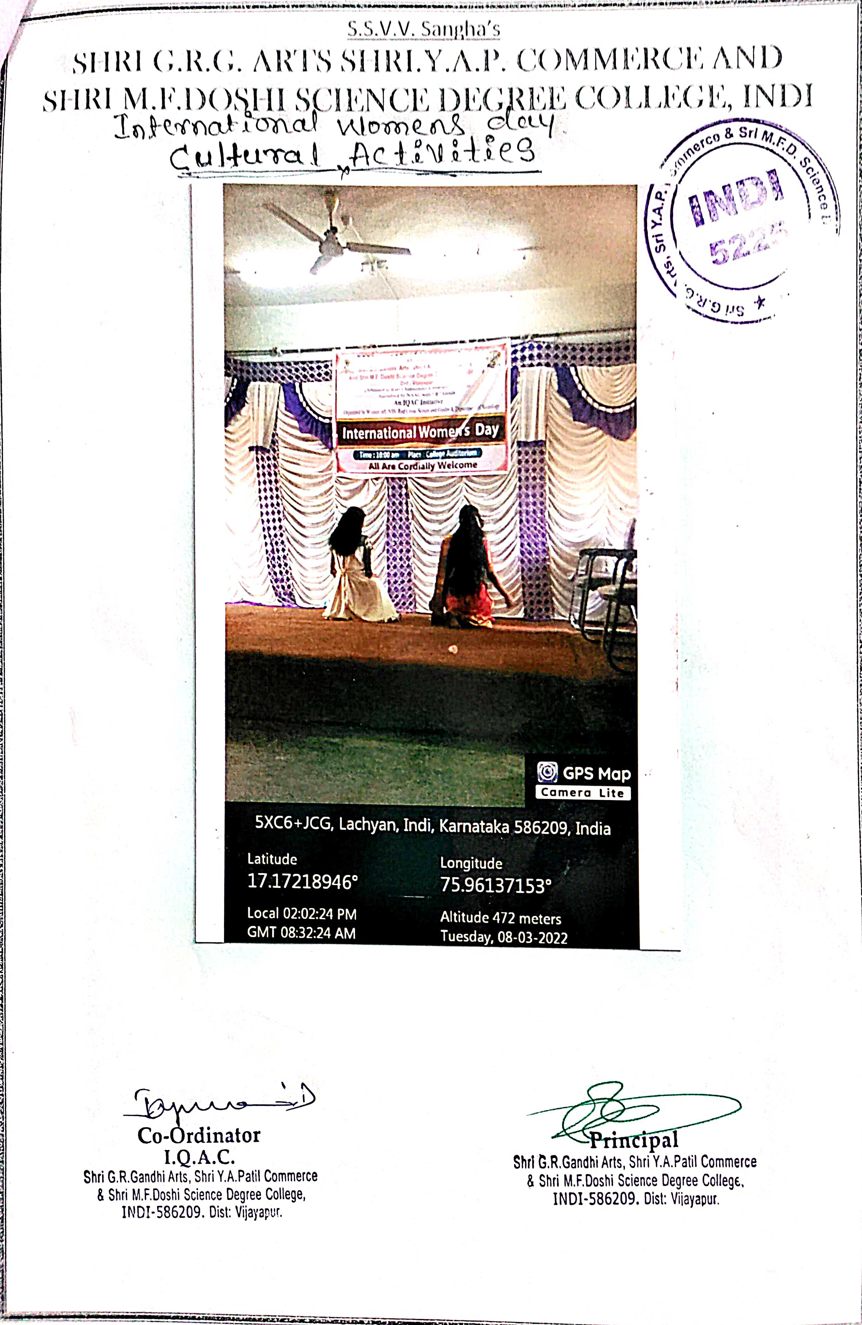

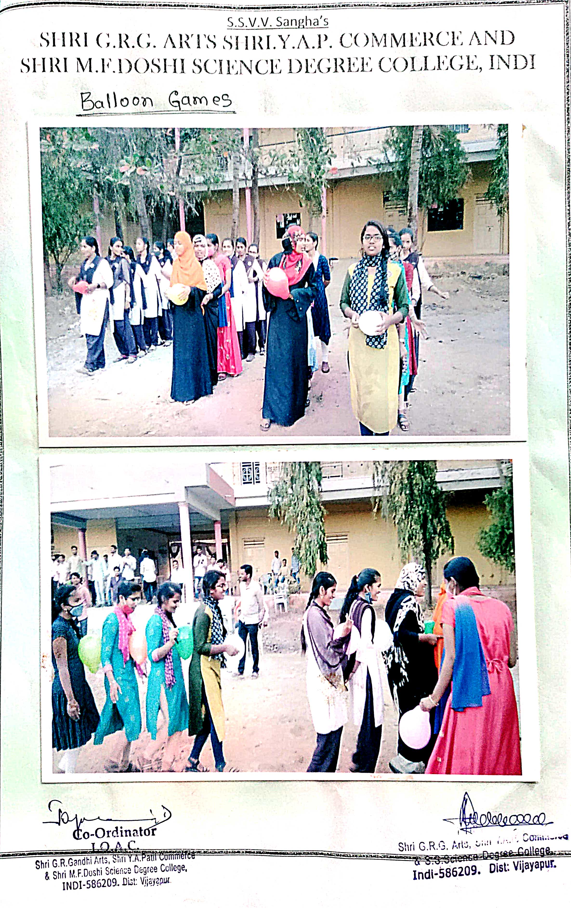
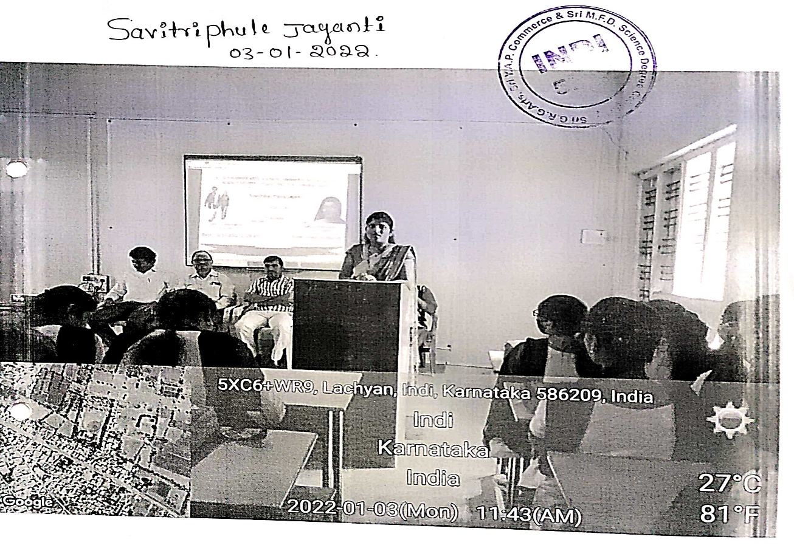
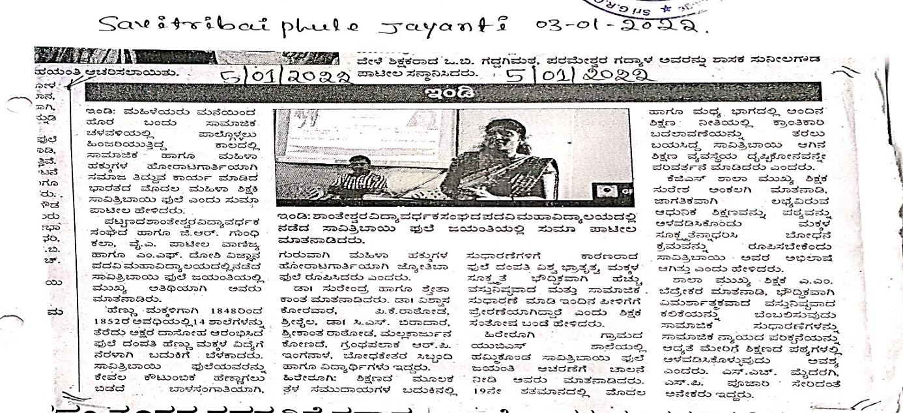
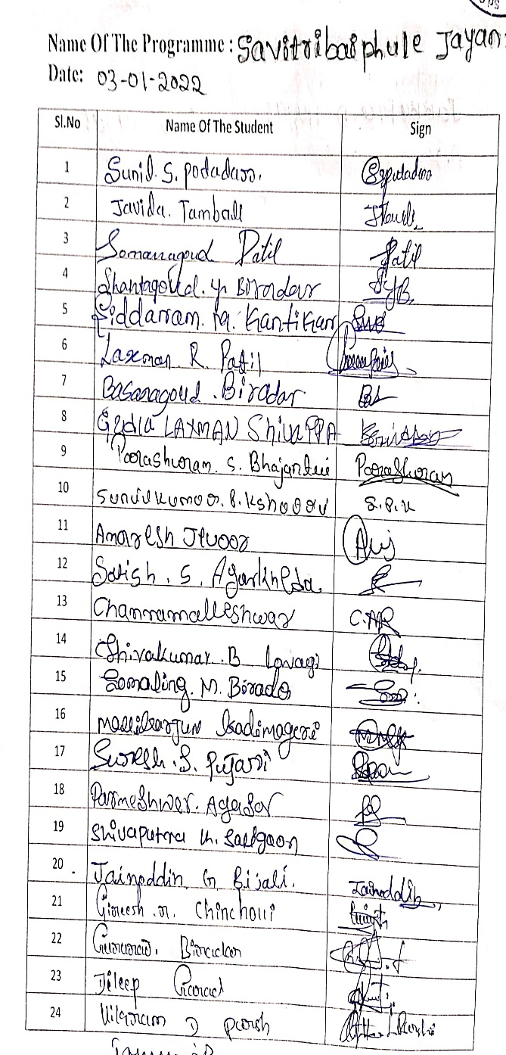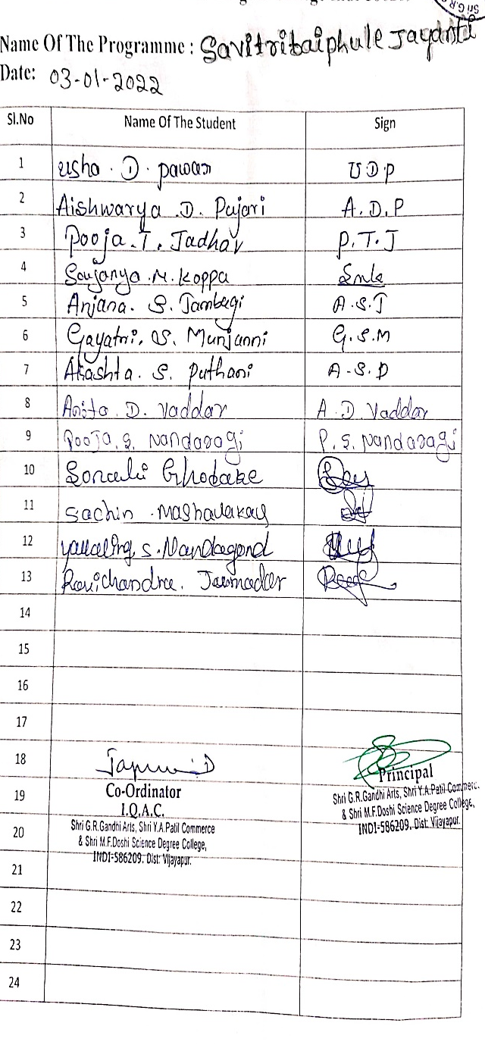

PROGAMME : GENDER EQUALITY IN POLITICS
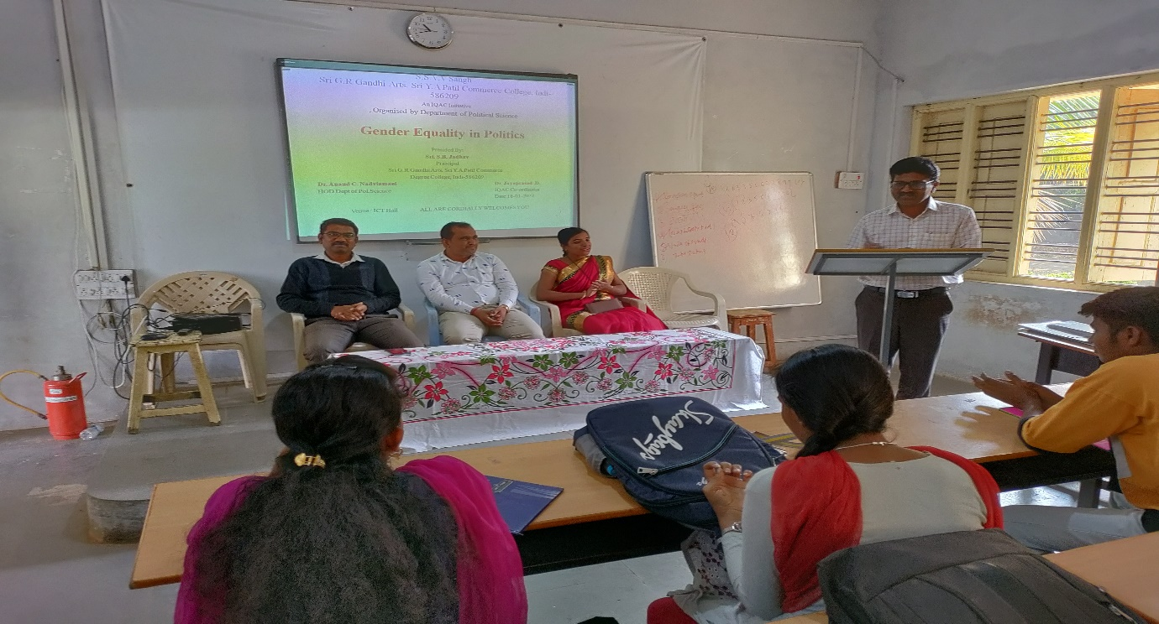
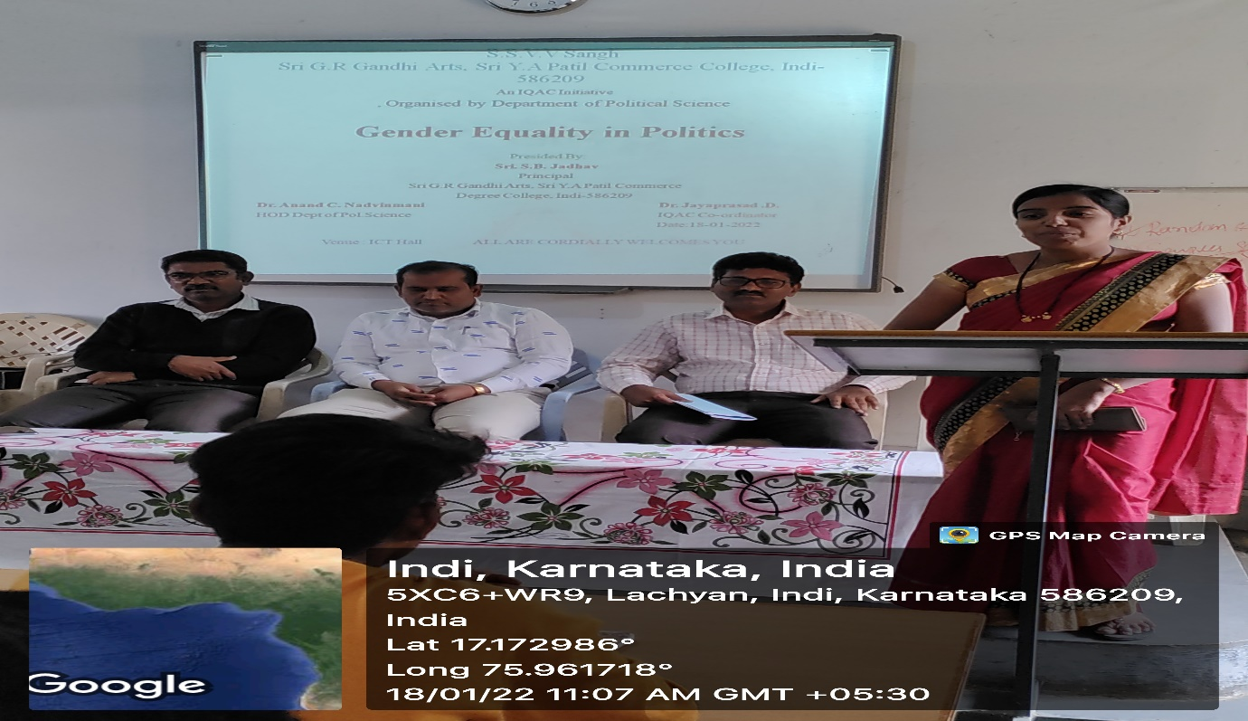

GENDER DISCRIMINATION LAWS IN INDIA
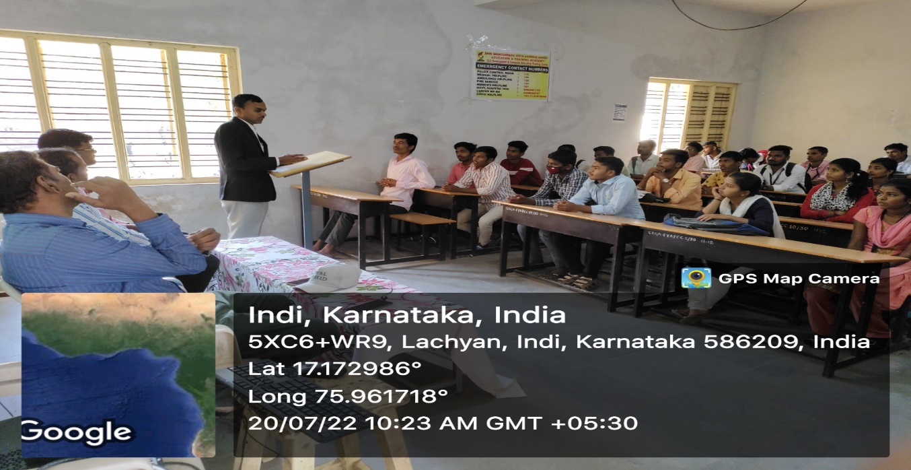

GENDER DISCRIMINATION LAWS IN INDIA
